Running head: Dashboard and Story line in Tableau

UK Bank Customers:

Dashboard and Story line in Tableau

Jai Katariya

University of Colorado, Denver

|  |  |  |
| --- | --- | --- |
| **Sr.** | **Index** | **Page No.** |
| **1** | **Abstract** | **3** |
| **2** | **The Dataset** | **3** |
| **3** | **The Objective** | **3** |
| **4** | **Overview:**  **UK Bank Customers – Dashboard in Tableau** | **4** |
| **5** | **England** | **6** |
| **6** | **Scotland** | **8** |
| **7** | **Tableau Dual Filter – Scotland** | **10** |
| **8** | **Wales** | **11** |
| **9** | **Northern Ireland** | **13** |
| **10** | **References** | **15** |

**Abstract**

This paper explores the UK Bank Customers dataset in Tableau. This paper starts with basic Map of UK to understand the dataset in Tableau with Basic nationality of the customers. It also tries to formulate business questions like “What is the target audience in different region” After this we try to answer the question with visuals and graphs with the help of Tableau interactive dashboard and storyline. We have 5 views to understand each variable is vital for our business question and perform customer segmentation by age, gender, job classification and region.

**The Dataset**

It is a dummy dataset for an imaginary bank in UK. It’s a new bank that is hoping to expand and run marketing campaigns at different regions depending upon the customer demographics like age, gender, job classification, balance, etc. It contains 4014 observation and 9 variables.

|  |  |  |
| --- | --- | --- |
| **Sr. No** | **Variable** | **Data Type** |
| 1 | Customer ID | Numeric |
| 2 | Name | String |
| 3 | Surname | String |
| 4 | Gender | String |
| 5 | Age | Numeric |
| 6 | Region | String |
| 7 | Job Classification | String |
| 8 | Date Joined | Date Time |
| 9 | Balance | Numeric |

**The Objective**

The objective here is to perform customer segmentation and capture the vital insights from interactive data visualization tool Tableau to help the marketing campaign in defining the target audience in each region.

**Overview: UK Bank Customers – Dashboard in Tableau**

The Dashboard has 5 views, helping us to get vital information and insights about the existing customers. It also helps the marketing department to lay the foundations for the target audience and next marketing campaign.

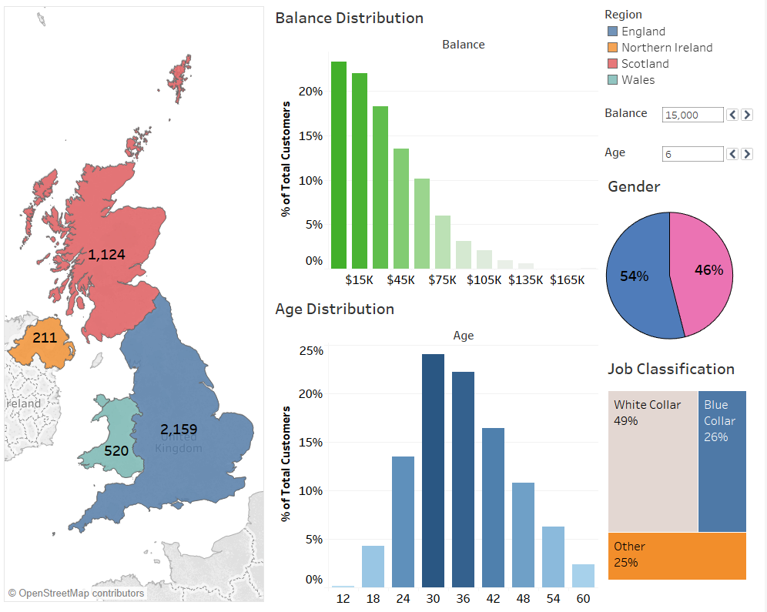

**Overview**

* From the map of UK we can notice that majority of the bank’s customers are from England.
* Majority of customers’ bank balance is below $50K mark.
* Average range for the age of the customers is 30 to 44.
* Gender is almost equal.
* Around 50% of customers are white collared, showing England been major contributor and London being the hub for white collar can be a reasonable explanation.

The above information sets a general overview of the current customer type. But marketing campaigns aren’t similar for all the regions. Therefore, with the help of Tableau and its interactive strengths, we can dissect the customer segment and help the marketing and sales department to target a particular type of customer in each region.

**Region Analysis**

Here, I’ll take each region and see if it is different from our general customer type.

1. **England**

Here, I have selected England and due to the interactive feature of Tableau other views highlights England’s contribution in them.

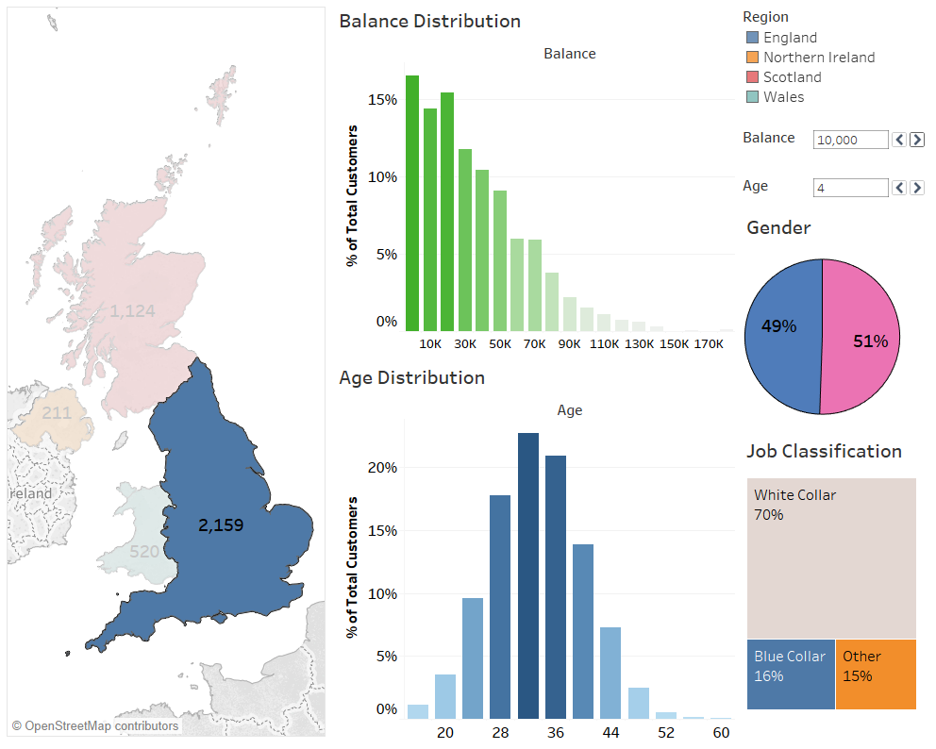

**Insights**

* The balance histogram is on an average similar to the overall UK balance.
* Age is an interesting feature as there is a huge drop after the age group of 35-37, which says England has younger customers compared to UK customers. This is something the marketing team should keep in mind while planning their strategies in England.
* 70% of the England’s customers are White Collar. This is important because it means the marketing team needs to target white collar people as they are the potential customers.
* Gender is equal.

**Targeting Recommendations for the Executives**

* England has 70% of the customers as white collar. Thus, the marketing department and sales department should target white collar and give offers **like investment plans and even long term mutual fund investments** that this specific audience who are in their early 30s can relate to.

1. **Scotland**

Here, I have selected Scotland and due to the interactive feature of Tableau, other views highlights Scotland’s contribution in them.

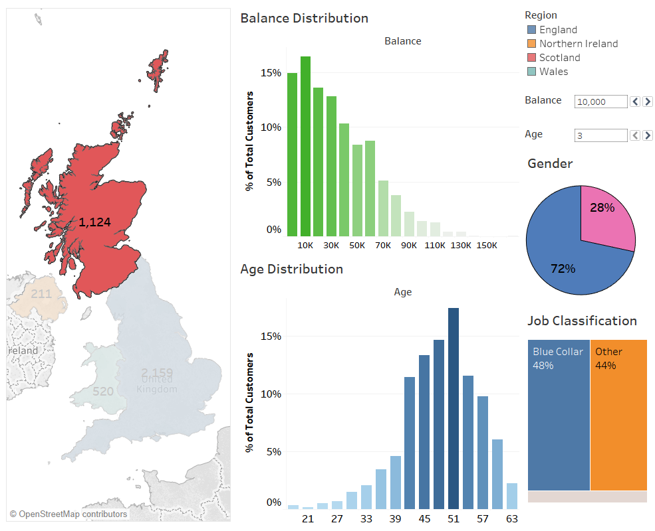

**Insights**

* The Bank Balance is slightly different than the UK’s overall bank balance. It is more like steps and the range has increased starting from $5K to $70K.
* Age is the most vital feature in Scotland, cratering to older customers with an age ranging from 45 to 55. The marketing and sales team needs to keep the age feature in mind when targeting Scotland and prepare ad campaigns accordingly.
* Scotland is a male-dominating country with respect to the existing customers since 72% of customers in Scotland are males.
* Lastly, Blue collar and others are dominating this region with 7% of white collar.

**Targeting Recommendations for the Executives**

* Scotland is dominated by old males with the job classification as blue collar and others. Thus, the marketing team should focus on old men in Scotland with good deals in **Retirement plans especially for blue collar type of customers**.

**Tableau Dual Filter**

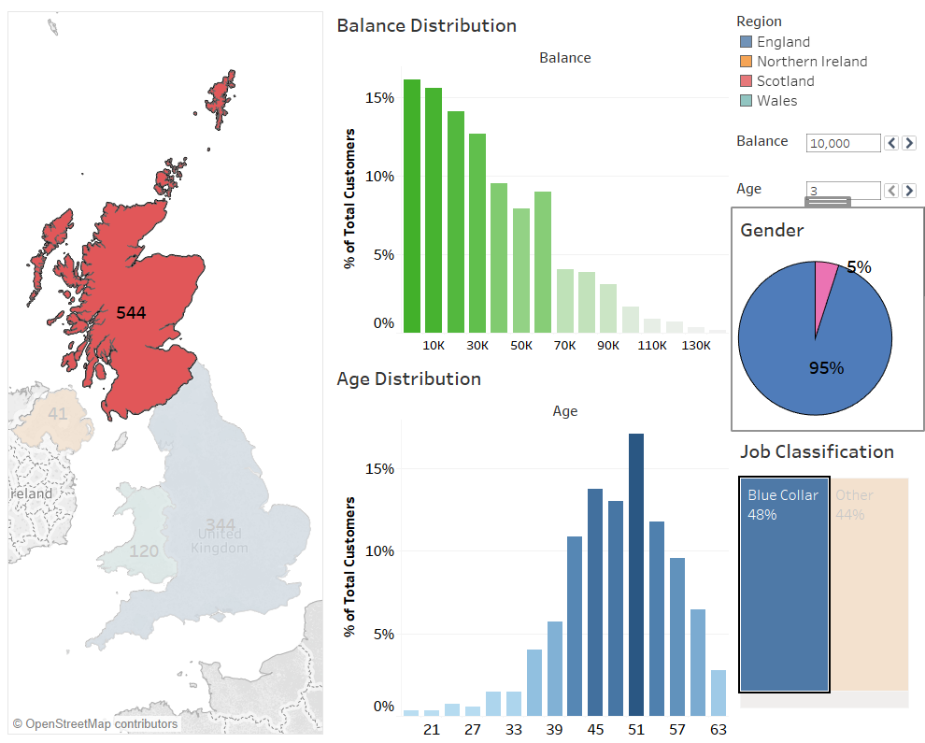

**Insights**

1. When we dissect the customer by Scotland and Blue collar, we get **95% of male dominated customer.**
2. **Wales**

Here, I have selected Wales and due to the interactive feature of Tableau, other views highlights Wales’s contribution in them.

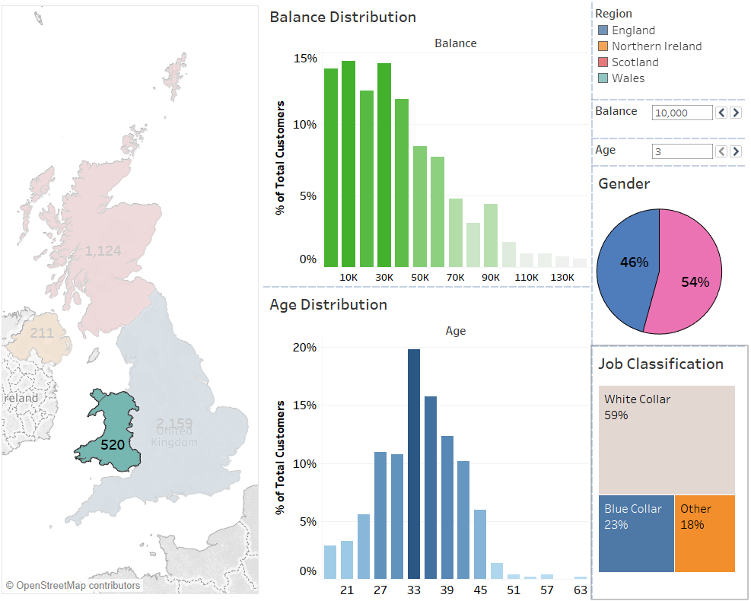

**Insights**

* The Bank Balance has been uniformed till $45K and then slides downwards.
* In Wales the age distribution is also quite uniformed ranging from 25 to 45, with a huge peak at 34, almost acting as an outlier.
* Gender is almost equal.
* Around 60% of customers in Wales, are white collared.

**Targeting Recommendations for the Marketing department**

* Wales has more of mid-30s, white collared customers. Thus, the marketing team should target them with benefits related to white collar jobs like **Investment plans and even Long Term Mutual Funds.**

1. **Northern Ireland**

Here, I have selected Northern Ireland and due to the interactive feature of Tableau other views highlights Northern Ireland’s contribution in them.

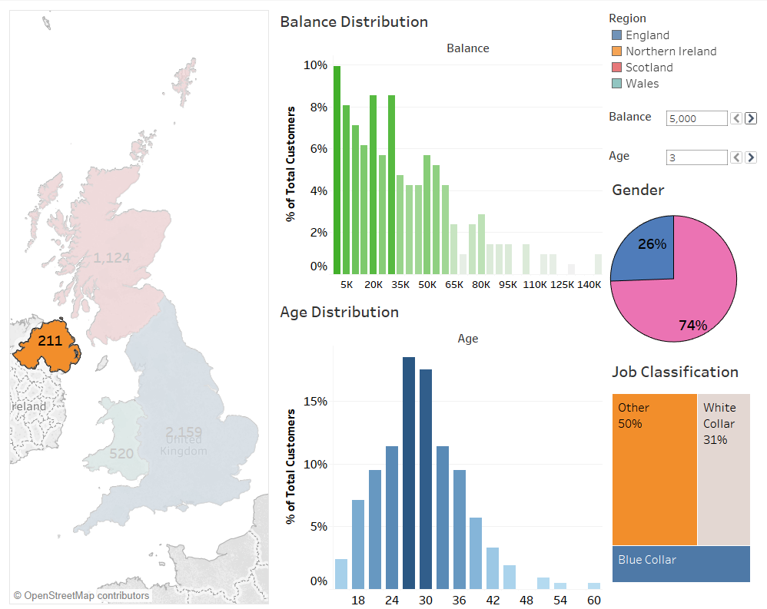

**Insights**

* The Bank Balance is different compared to UK’s overall bank balance. It has high bumps at $20K and $30K. This allows the promotional team to have some insights like giving benefits for keeping a balance around $20K to $30K, which attracts the younger generation to be the potential customer.
* Age is the most vital feature in Northern Ireland as represent the younger customers ranging from 24 to 33. Although it is a small market but if the marketing department targets the younger generation, it can be one of the potential markets in the upcoming years. Also there is a huge gap between 47 and 52 age group.
* Job Classification is another good variable suggesting that unlike other regions it has lower white and blue-collar customers. Here, Job Classification represents 50% as Others.
* Gender is 74% females, which can totally help the marketing department.

**Targeting Recommendations for the Marketing department**

* Northern Ireland has more young women. Thus, the marketing teams should target young women with benefits of having balances around $30K and can offer **Educational loans** **for women.**

**Reference**

<https://www.superdatascience.com/>